Loops are used to execute one or more statements multiple times until a specified condition is fulfilled. There are many loops in C# such as for loop, while loop, do while loop etc.

For loop

While loop

Do while loop

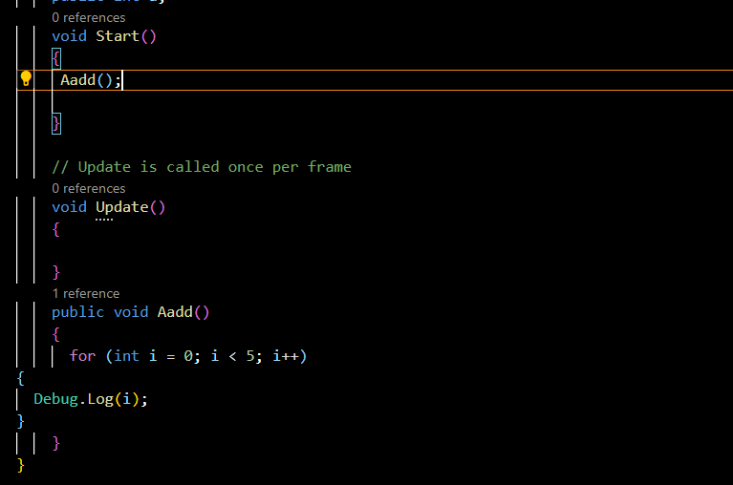

Output

